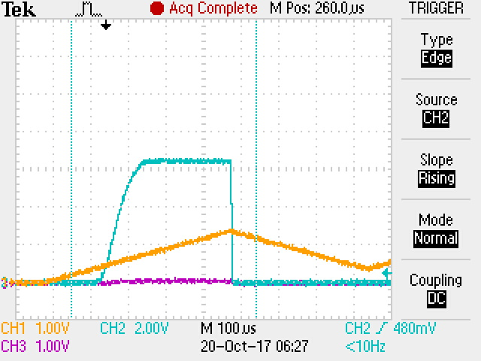

Figure : TPS Switch #5, 12 Ohm load

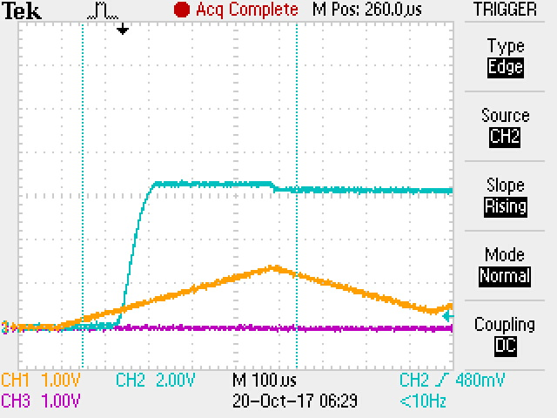

Figure : TPS Switch #5, no load

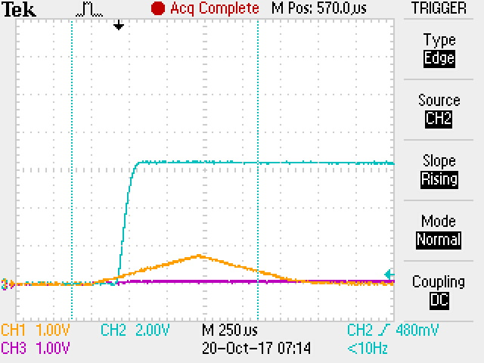

Figure : Switch #4 with 10 nF instead of 3.9 nF C_TIMER. Steady-state IMON = 0.085 V

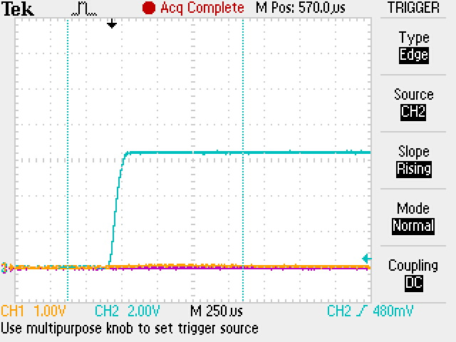

Figure : TPS switch, 12 Ohm load, steady stae IMON = 0.002 V, C_TIMER = 0.1 uF

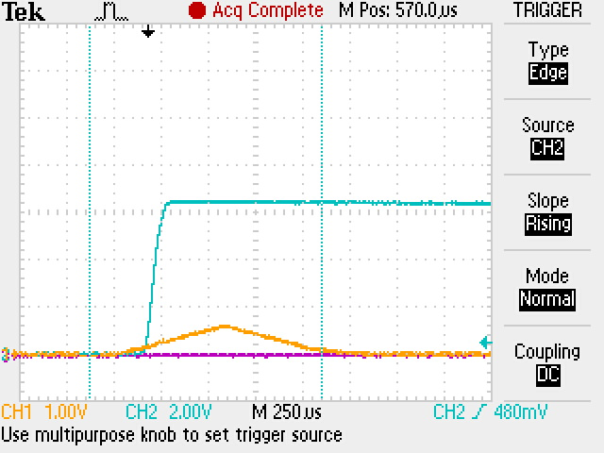

Figure : PPT Switch w/ 10 nF cap on C_TIMER, Load = 12 Ohm